Feature Selection Methods for
Breast Cancer Prediction
Univariate and Multivariate Approaches with Logistic Regression
Dataset: Wisconsin Breast Cancer Diagnostic (UCI Repository)
Evaluation Method: 10-Fold Stratified Cross-Validation

1. Data Overview

1.1 Dataset Description
The Wisconsin Breast Cancer Diagnostic (WBCD) dataset, available from the UCI Machine Learning Repository (ID: 17), is one of the most widely used benchmarks in medical machine learning research. It was created by Dr. William H. Wolberg at the University of Wisconsin–Madison and contains digitized measurements derived from fine-needle aspiration (FNA) biopsy images of breast masses.

Each sample in the dataset represents one patient biopsy, and the outcome is a binary classification: Malignant (M) or Benign (B). The dataset contains 569 observations with 30 numeric features and no missing values, making it an ideal benchmark for evaluating feature selection techniques.

1.2 Dataset Summary Statistics
Property | Value | Property | Value | Property | Value
Total samples | 569 | Total features | 30 | Missing values | 0 (none)
Benign (0) | 357 (62.7%) | Malignant (1) | 212 (37.3%) | Data type | All numeric
Feature groups | 3 × 10 = 30 | Evaluation | 10-fold CV | Baseline model | Logistic Regression

1.3 Feature Description
The 30 features are computed from digitized images of FNA biopsies. For each of 10 nuclear characteristics, three statistical measures are captured: the mean value, the standard error (SE), and the "worst" (largest) value observed among the cell nuclei in the image. The 10 characteristics are:

# | Characteristic | Description | 3 Statistics Captured
1 | Radius | Mean distance from center to perimeter points of the nucleus | Mean, SE, Worst
2 | Texture | Standard deviation of grey-scale intensity values | (same as above)
3 | Perimeter | Perimeter of the cell nucleus boundary | (same as above)
4 | Area | Area enclosed by the cell nucleus boundary | (same as above)
5 | Smoothness | Local variation in radius lengths (shape regularity) | (same as above)
6 | Compactness | Perimeter² / Area − 1.0 (shape compactness ratio) | (same as above)
7 | Concavity | Severity of concave portions of the nucleus contour | (same as above)
8 | Concave points | Number of concave portions of the nucleus contour | (same as above)
9 | Symmetry | Symmetry of the cell nucleus shape | (same as above)
10 | Fractal dimension | "Coastline approximation" – 1 (boundary complexity) | (same as above)

This yields 30 total features: 10 mean features (e.g., mean radius), 10 SE features (e.g., radius error), and 10 worst features (e.g., worst radius). All features are continuous, real-valued, and non-negative.

2. Exploratory Data Analysis

2.1 Class Distribution
The dataset contains 357 benign cases (62.7%) and 212 malignant cases (37.3%). While there is a class imbalance, the ratio is moderate (~1.68:1) and does not require aggressive resampling strategies. We use stratified cross-validation throughout to ensure each fold preserves the class distribution.

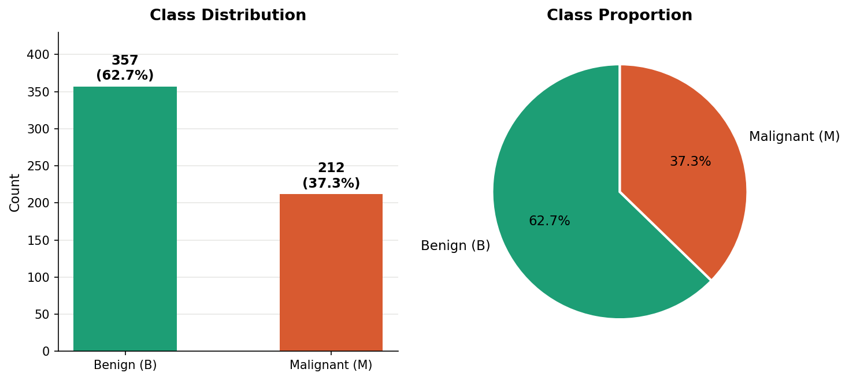
Figure 1. Class distribution in the Wisconsin Breast Cancer dataset. Left: absolute counts. Right: proportional split.

2.2 Univariate Analysis — Feature Distributions
The histograms below show the distribution of each of the 10 mean features, split by diagnosis. Malignant tumors (orange) consistently show higher values for size-related features (radius, perimeter, area) and shape irregularity features (concavity, concave points, compactness) compared to benign cases (teal). Features such as smoothness and fractal dimension show less separation, suggesting lower discriminatory power.

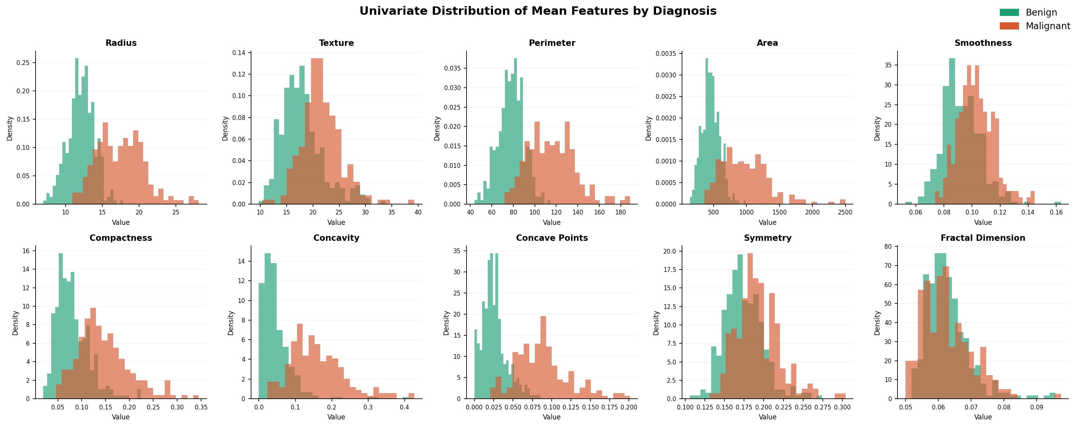
Figure 2. Univariate density distributions for the 10 mean features, stratified by diagnosis class.

2.3 Bivariate Analysis — Feature vs. Target
Box plots provide a clearer picture of separation between classes. Features with high AUC values (>0.90) show minimal overlap between benign and malignant distributions. The top-ranked features — worst concave points (AUC = 0.981), worst perimeter (AUC = 0.978), and mean concave points (AUC = 0.976) — demonstrate excellent individual discriminative power. The AUC values in figure captions represent single-feature logistic regression performance.

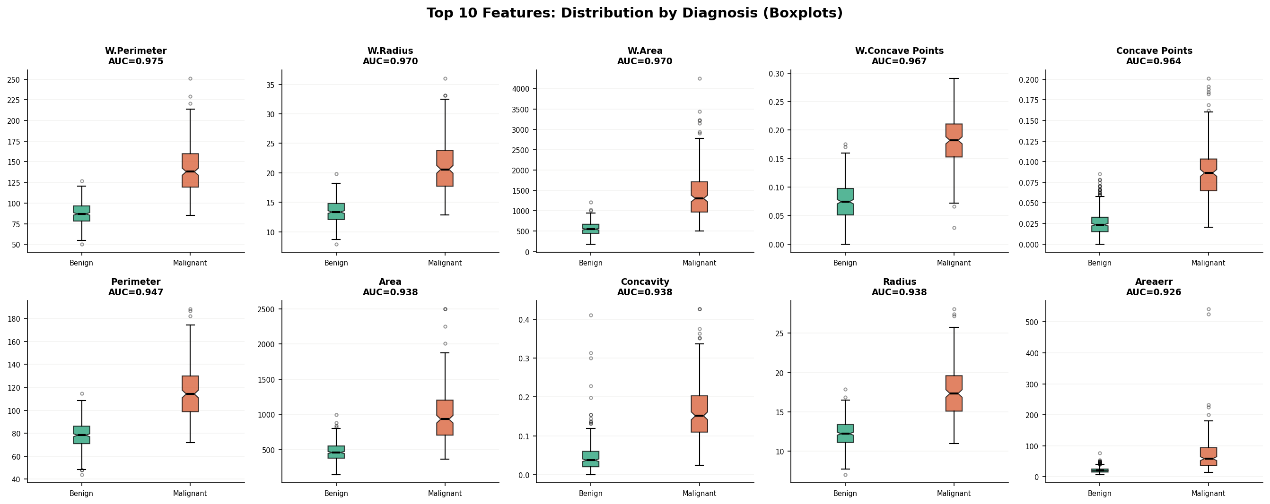
Figure 3. Box plots for the top 10 features ranked by individual AUC. Notches indicate median confidence intervals; non-overlapping notches suggest statistically significant medians.

2.4 Bivariate Scatter Plots
Scatter plots reveal the joint relationship between feature pairs. Size-related features (radius, perimeter, area) are strongly correlated with their "worst" counterparts, as expected — this multicollinearity is important context for multivariate feature selection, which explicitly accounts for redundancy between features.

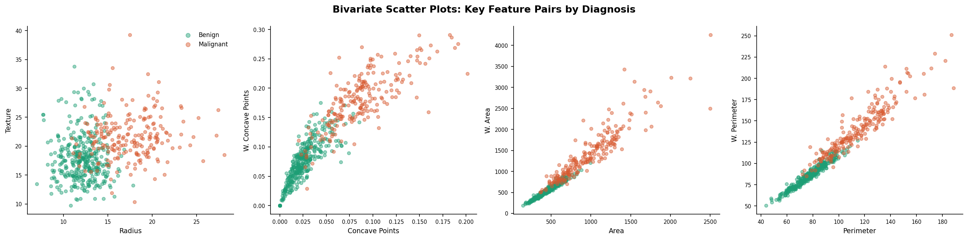
Figure 4. Bivariate scatter plots for selected feature pairs, coloured by diagnosis. Strong linear relationships between mean and worst versions indicate high inter-feature correlation.

2.5 Feature Correlation Structure
The correlation heatmap reveals strong multicollinearity among the 30 features. Size-related features (radius, perimeter, area) form a tight cluster with Pearson correlations exceeding 0.98. Shape features (concavity, concave points, compactness) form a second correlated cluster. This high redundancy motivates the use of multivariate selection methods that explicitly penalise redundant feature sets.

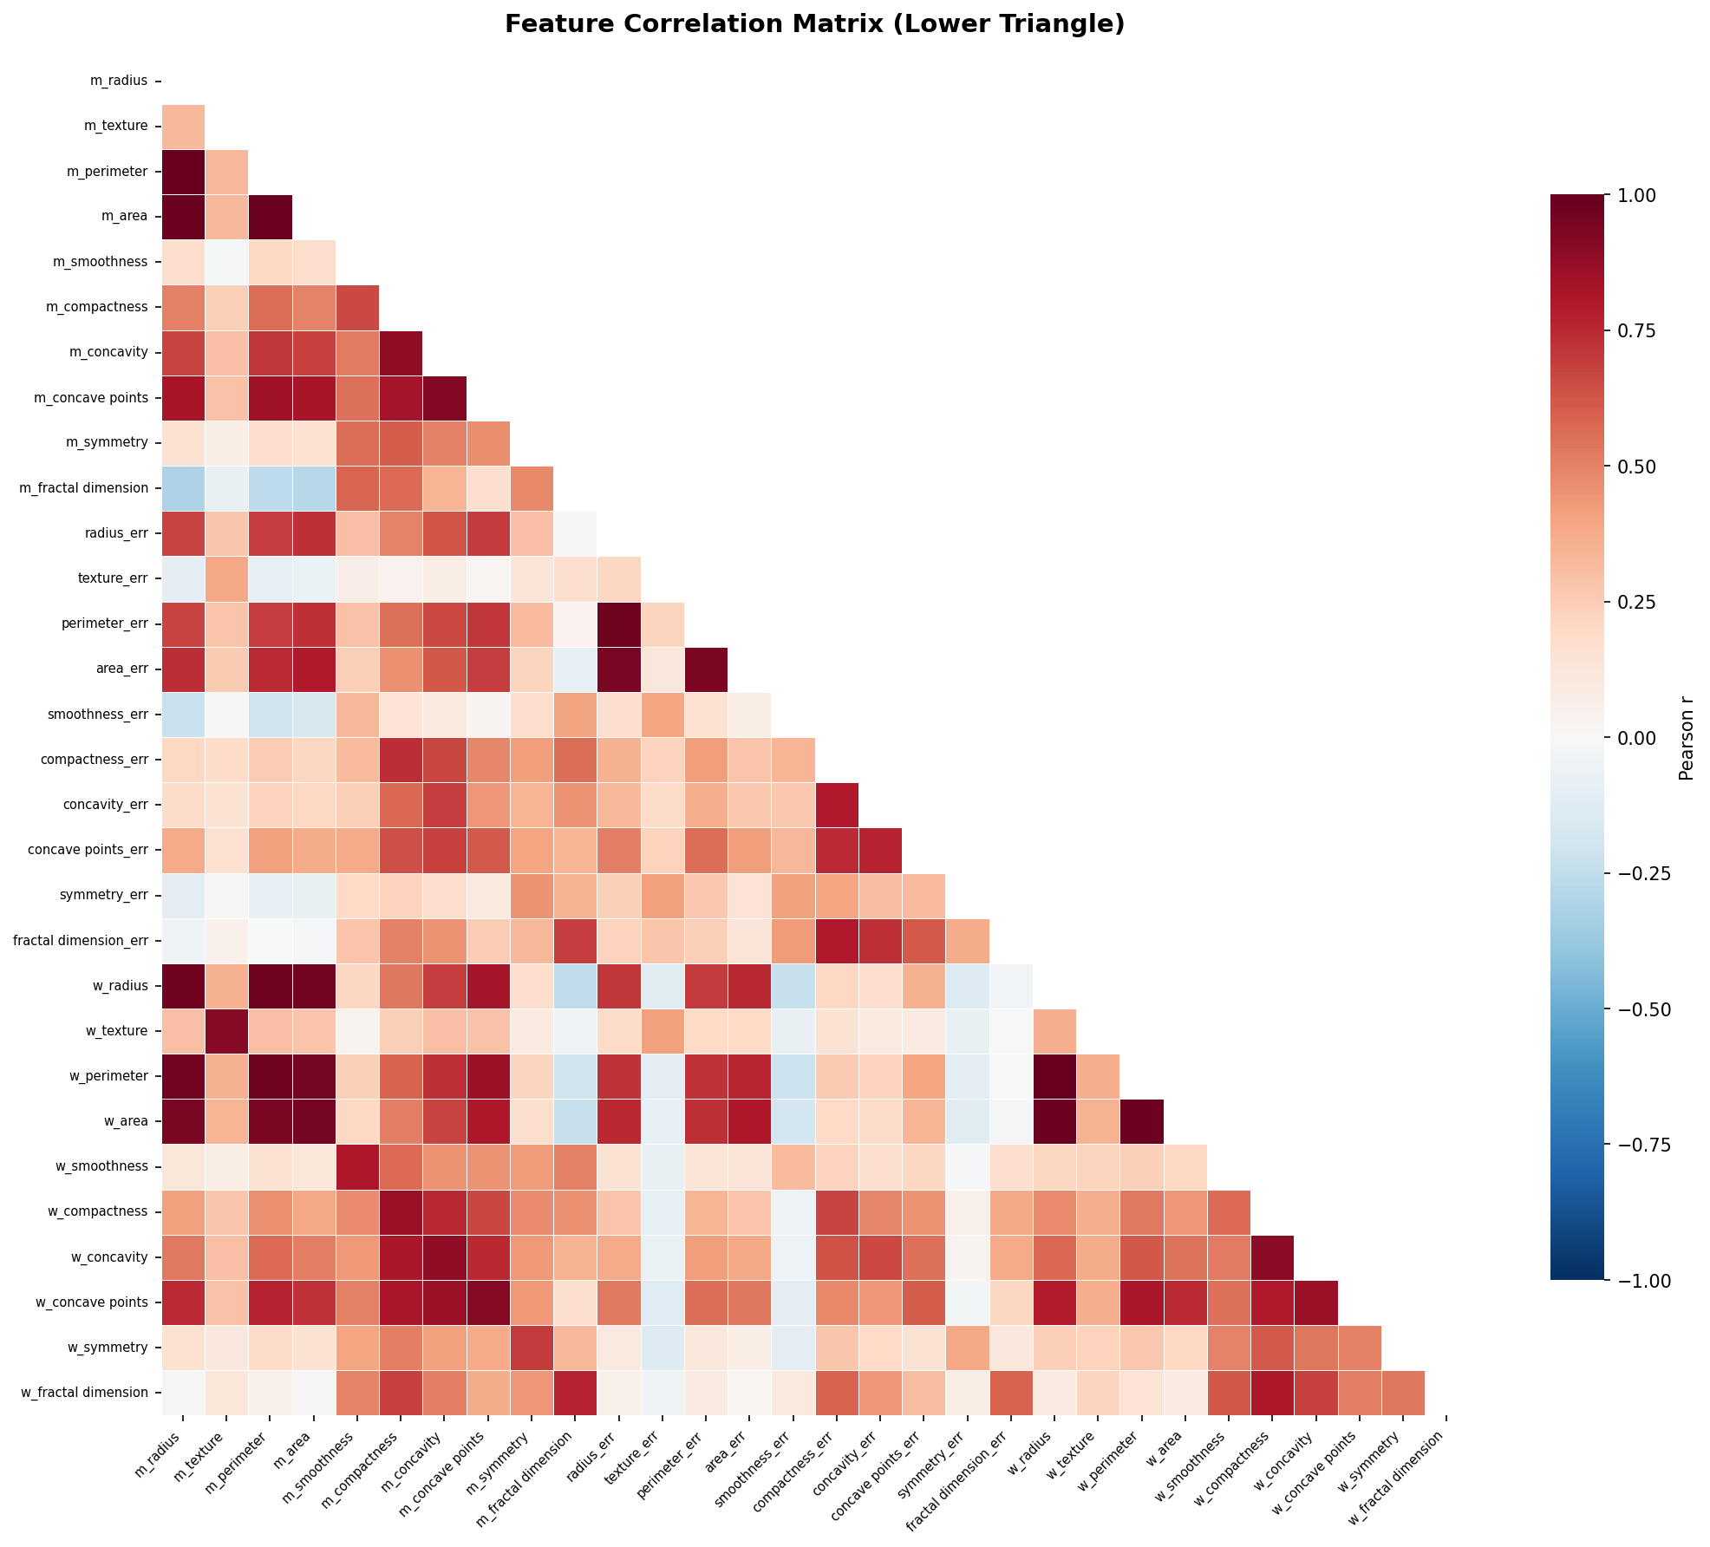
Figure 5. Pearson correlation matrix (lower triangle) across all 30 features. Deep red indicates strong positive correlation; deep blue indicates strong negative correlation.

3. Baseline Model — Logistic Regression (All 30 Features)
Before applying any feature selection, we establish a baseline using Logistic Regression trained on all 30 standardized features. The model is evaluated using 10-fold stratified cross-validation with five metrics: accuracy, precision, recall, F1-score, and AUC-ROC. Standardization (zero mean, unit variance) is applied within each fold to prevent data leakage.

3.1 Rationale for Logistic Regression
Logistic Regression is an appropriate baseline for this task because: (1) it is interpretable and widely used in clinical decision support; (2) it provides calibrated probability estimates; (3) it is robust to the moderate class imbalance present here; and (4) its performance with different feature subsets is directly comparable, isolating the effect of feature selection from model complexity.

3.2 Baseline Performance
Model | N Features | Accuracy | Precision | Recall | F1 | AUC
Baseline (All 30 features) | 30 | 0.9772 | 0.9820 | 0.9574 | 0.9686 | 0.9947

The baseline model achieves excellent performance: 97.7% accuracy, 98.2% precision, and an AUC of 0.995. This represents an upper bound that feature selection methods will be benchmarked against. The high precision is particularly valuable in the clinical context — it means that when the model predicts malignancy, it is rarely wrong, which reduces unnecessary procedures. However, the recall of 95.7% suggests that some malignant cases are missed; for cancer screening, high recall is the priority.

A key concern with using all 30 features is the potential for overfitting, high computational cost, and reduced interpretability. With 569 samples and 30 features (~19 samples per feature), the model is relatively data-efficient, but in practice, leaner models are preferred for clinical deployment.

4. Univariate Feature Selection Methods
Univariate feature selection methods evaluate each feature independently against the target variable, without considering interactions or redundancy between features. They are computationally efficient and easy to interpret, but may select redundant features. We apply four univariate methods: Pearson Correlation, ANOVA/t-test, Chi-Square, and ReliefF.

4.1 Pearson Correlation

4.1.1 Method Description
Pearson correlation measures the linear relationship between each feature and the binary target variable. For feature Xⱼ and target Y, the Pearson coefficient is:

r(Xⱼ, Y) = Σ[(Xⱼᵢ − X̄ⱼ)(Yᵢ − Ȳ)] / √[Σ(Xⱼᵢ − X̄ⱼ)² · Σ(Yᵢ − Ȳ)²]

Features are ranked by |r| and the top-K are retained. Higher |r| values indicate stronger linear association. This method assumes a linear relationship; non-linear relationships may be underestimated.

4.1.2 Top Features (Pearson)
Rank | Feature | |r| | Rank | Feature | |r|
1 | worst concave points | 0.7936 | 2 | worst perimeter | 0.7829
3 | mean concave points | 0.7766 | 4 | worst radius | 0.7765
5 | mean perimeter | 0.7426 | 6 | worst area | 0.7338
7 | mean radius | 0.7300 | 8 | mean area | 0.7090
9 | mean concavity | 0.6964 | 10 | worst concavity | 0.6596

Observation: Pearson correlation strongly favours size and shape irregularity features ("worst" and "mean" versions of concave points, perimeter, radius, area). The top 4 features all concern tumour boundary irregularity — a clinically meaningful signal.

4.2 ANOVA F-Test

4.2.1 Method Description
The ANOVA F-test (equivalent to a t-test for binary classification) assesses whether the means of a feature differ significantly between the two diagnostic groups. The F-statistic is calculated as:

F = Between-group variance / Within-group variance = (n₀·(x̄₀ − x̄)² + n₁·(x̄₁ − x̄)²) / (Σ(xᵢ − x̄ₖ)²/(n−2))

A higher F-value indicates greater group separation relative to within-group variability. Unlike Pearson, F-test does not assume a specific direction of effect, only group difference. The p-values for all top features are astronomically small (p < 10⁻⁷²), confirming highly significant differences between benign and malignant groups.

4.2.2 Top Features (ANOVA F-Test)
Rank | Feature | F-Statistic | p-value | Interpretation
1 | worst concave points | 964.39 | 1.97×10⁻¹²⁴ | Highly significant
2 | worst perimeter | 897.94 | 5.77×10⁻¹¹⁹ | Highly significant
3 | mean concave points | 861.68 | 7.10×10⁻¹¹⁶ | Highly significant
4 | worst radius | 860.78 | 8.48×10⁻¹¹⁶ | Highly significant
5 | mean perimeter | 697.24 | 8.44×10⁻¹⁰¹ | Highly significant
6 | worst area | 661.60 | 2.83×10⁻⁹⁷ | Highly significant
7 | mean radius | 646.98 | 8.47×10⁻⁹⁶ | Highly significant
8 | mean area | 573.06 | 4.73×10⁻⁸⁸ | Highly significant
9 | mean concavity | 533.79 | 9.97×10⁻⁸⁴ | Highly significant
10 | worst concavity | 436.69 | 2.46×10⁻⁷² | Highly significant

Result: The ANOVA ranking is virtually identical to Pearson correlation for this dataset, which is expected when the target is binary and the features are continuous. The extremely low p-values demonstrate robust statistical significance across the top features.

4.3 Chi-Square Test

4.3.1 Method Description
The Chi-Square test of independence measures the dependency between each feature and the target by comparing observed versus expected frequencies. Since Chi-Square requires non-negative inputs, features are first scaled to [0, 1] using Min-Max normalization. The test statistic is:

χ² = Σ [(Observed − Expected)² / Expected]

Chi-Square is commonly used for categorical features but can be applied to continuous features after binning or normalization. It captures non-linear monotonic associations that Pearson may miss, but is sensitive to the number of bins chosen.

The Chi-Square formula: sklearn's chi2() does not bin continuous values. Instead it treats each scaled value as a pseudo-count and computes observed versus expected sums per class. This works because after MinMax scaling, all values are non-negative, which is the only mathematical requirement Chi-Square has.

4.3.2 Top Features (Chi-Square)
Rank | Feature | χ² Score | Rank | Feature | χ² Score
1 | mean concave points | 52.41 | 2 | worst concave points | 46.34
3 | mean concavity | 46.19 | 4 | worst area | 35.04
5 | worst perimeter | 34.44 | 6 | worst radius | 34.12
7 | worst concavity | 31.56 | 8 | mean area | 29.33
9 | mean perimeter | 26.53 | 10 | mean radius | 24.90

Observation: Chi-Square produces a slightly different ordering compared to Pearson/ANOVA — notably, mean concave points is ranked #1 rather than worst concave points. However, the same set of 10 features is selected by all three methods, yielding identical model performance.

4.4 ReliefF

4.4.1 Method Description
ReliefF is an instance-based feature weighting algorithm that estimates feature quality based on how well each feature distinguishes between near-neighbour instances from the same and different classes. For each sample, it finds k nearest hits (same class) and k nearest misses (different class) and updates feature weights:

W(Xⱼ) = W(Xⱼ) − Σ diff(Xⱼ, xᵢ, hit)/n + Σ diff(Xⱼ, xᵢ, miss)/n

ReliefF is non-parametric, does not assume linearity, and is sensitive to feature interactions. It is more robust to redundant features than purely correlation-based methods, and can handle both continuous and discrete features. We use k=10 nearest neighbours in this implementation.

4.4.2 Top Features (ReliefF)
Rank | Feature | Weight | Rank | Feature | Weight
1 | worst radius | 0.5985 | 2 | worst perimeter | 0.5806
3 | worst area | 0.5481 | 4 | worst texture | 0.5052
5 | worst concave points | 0.4939 | 6 | mean perimeter | 0.4677
7 | mean radius | 0.4663 | 8 | mean area | 0.4513
9 | mean concave points | 0.4352 | 10 | mean texture | 0.3731

Key difference: ReliefF selects a distinct set of features compared to the correlation-based methods. Notably, worst texture (ranked #4) and mean texture (ranked #10) appear — features not in the top 10 of Pearson/ANOVA/Chi-Square. This is because ReliefF considers the local neighbourhood structure of the data and can detect features that are discriminative even without a strong global linear correlation.

4.5 Univariate Feature Selection: Model Performance
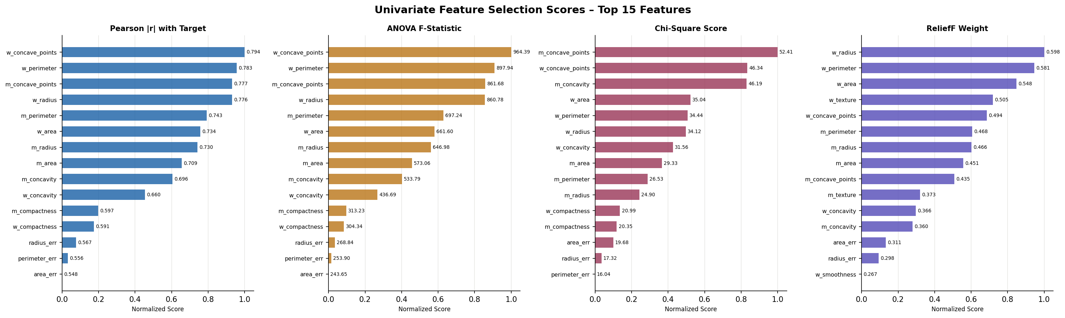
Figure 6. Normalized feature importance scores from the four univariate selection methods (top 15 features shown). Note that Pearson, ANOVA, and Chi-Square select the same top 10 features while ReliefF produces a distinct ranking.
Model | N Feats | Accuracy | Precision | Recall | F1 | AUC
Baseline (All 30) | 30 | 0.9772 | 0.9820 | 0.9574 | 0.9686 | 0.9947
Pearson (top 10) | 10 | 0.9561 | 0.9471 | 0.9335 | 0.9387 | 0.9885
ANOVA (top 10) | 10 | 0.9561 | 0.9471 | 0.9335 | 0.9387 | 0.9885
Chi-Square (top 10) | 10 | 0.9561 | 0.9471 | 0.9335 | 0.9387 | 0.9885
ReliefF (top 10) | 10 | 0.9667 | 0.9687 | 0.9431 | 0.9538 | 0.9937

Key findings from univariate selection:
- Pearson, ANOVA, and Chi-Square select the same top 10 features, producing identical model performance (Accuracy: 95.6%, AUC: 0.989). This is unsurprising since all three fundamentally measure linear association between feature and target.
- ReliefF produces a different feature set and achieves notably better performance (Accuracy: 96.7%, AUC: 0.994), closer to the baseline. This reflects ReliefF's ability to capture non-linear, interaction-based discriminative signals.
- All univariate methods reduce accuracy by approximately 1–2% compared to the 30-feature baseline, but achieve a 67% reduction in dimensionality (30 → 10 features), which is a favourable trade-off.
- The reduction in precision from 98.2% (baseline) to 94.7–96.9% suggests that some discriminative information is lost, but the models remain clinically useful.

5. Multivariate Feature Selection Methods
Multivariate feature selection methods consider interactions and redundancies among features simultaneously. They tend to produce more compact, non-redundant feature subsets compared to univariate methods. We apply three multivariate methods: Correlation-Based Feature Subset Selection (CFS), Consistency-Based Feature Subset Selection (CON), and Double Input Symmetric Relevance (DISR).

5.1 Correlation-Based Feature Subset Selection (CFS)

5.1.1 Method Description
CFS, introduced by Hall (1999), evaluates subsets of features based on a merit function that rewards features that are highly correlated with the class label but weakly correlated with each other. The merit of a subset S of k features is:

Merit(S) = k · r̄cf / √(k + k(k−1) · r̄ff)

where r̄cf is the average feature–class correlation and r̄ff is the average feature–feature inter-correlation. A greedy best-first search is used to find the subset that maximises merit. CFS explicitly penalises redundant features: if adding a new feature only adds information that is already captured by an existing feature, the merit does not increase.

5.1.2 Results (CFS)
CFS selected only 2 features: worst concave points and worst radius, with a merit score of 0.830. This is an extremely compact representation — just 2 features out of 30. The method eliminates all other features because they are either highly correlated with these two (e.g., perimeter, area, and concavity) or insufficiently correlated with the class label.

5.2 Consistency-Based Feature Subset Selection (CON)

5.2.1 Method Description
The Consistency-based method (Liu & Setiono, 1996) selects the minimum feature subset that maintains classification consistency — meaning the selected features do not introduce ambiguity in class labels. The inconsistency rate measures the proportion of training examples that share the same feature values but have different class labels. Features are added in order of mutual information with the target until the inconsistency rate drops below a threshold (τ = 0.05 in our implementation):

Inconsistency Rate = (Σ|groupᵢ| − max_class(groupᵢ)) / N

This method is conceptually appealing for medical datasets where class ambiguity is undesirable. Unlike CFS, it does not require a continuous measure of correlation — it only cares about whether the selected features can distinguish between classes without contradiction.

5.2.2 Inconsistency Rate Reduction (CON)
Step | Feature Added | Inconsistency Rate | Status
1 | worst perimeter | 0.1617 | Insufficient (>0.05)
2 | worst area | 0.1142 | Insufficient (>0.05)
3 | worst radius | 0.1142 | Insufficient (>0.05)
4 | mean concave points | 0.0791 | Insufficient (>0.05)
5 | worst concave points | 0.0598 | Insufficient (>0.05)
6 | mean perimeter | 0.0510 | Insufficient (>0.05)
7 | mean concavity | 0.0404 | ✓ Threshold met (≤0.05)

CON required 7 features to achieve an inconsistency rate of 0.040 (<0.05). Importantly, the selected subset is conceptually meaningful: it combines the "worst" versions of size features (perimeter, area, radius) with shape irregularity features (concave points, concavity), representing the tumour boundary characteristics most associated with malignancy.

5.3 Double Input Symmetrical Relevance (DISR)

5.3.1 Method Description
DISR (Meyer & Bontempi, 2006) is an information-theoretic filter method that ranks features based on their joint relevance with the target given the already-selected features. The DISR criterion for a candidate feature Xc given a selected set S is:

DISR(Xc | S) = (1/|S|) · Σₛ∈S [I(Xc, Xs; Y) / (I(Xc; Y) + I(Xs; Y))]

where I(Xc, Xs; Y) is the joint mutual information of features Xc and Xs with the target Y. DISR rewards features that, in combination with already-selected features, provide maximum information about Y — explicitly favouring complementary, non-redundant features. Features are discretized into bins prior to mutual information computation.

5.3.2 Features Selected (DISR)
DISR selected 10 features through greedy forward selection. Notably, the selected features are quite different from both the univariate methods and CFS/CON. DISR favours features that provide complementary information when considered jointly, leading to a diverse selection of shape and texture features.

5.3.3 DISR Selected Feature Set
Rank | Feature Selected | Interpretation
1 | worst perimeter | Strong size/malignancy indicator (anchor feature)
2 | smoothness error | Complementary local shape irregularity signal
3 | texture error | Grey-scale variability within the cell nucleus
4 | symmetry error | Asymmetry variation across nuclei
5 | mean fractal dimension | Boundary complexity (coastline approximation)
6 | fractal dimension error | Variation in boundary complexity
7 | worst fractal dimension | Maximum boundary complexity observed
8 | mean smoothness | Average local radius variation
9 | mean symmetry | Shape symmetry of nuclei
10 | worst smoothness | Maximum local radius variation

DISR's feature set is strikingly different: it selects many "error" (SE) features and texture/smoothness features that are largely ignored by other methods. This reflects the information-theoretic principle of complementarity — once worst perimeter is selected, DISR looks for features that add new, non-redundant information, rather than correlated surrogates.

5.4 Multivariate Feature Selection: Model Performance
Model | N Feats | Accuracy | Precision | Recall | F1 | AUC
Baseline (All 30) | 30 | 0.9772 | 0.9820 | 0.9574 | 0.9686 | 0.9947
CFS (2 features) | 2 | 0.9456 | 0.9300 | 0.9240 | 0.9244 | 0.9860
CON (7 features) | 7 | 0.9561 | 0.9528 | 0.9288 | 0.9392 | 0.9877
DISR (10 features) | 10 | 0.9561 | 0.9655 | 0.9193 | 0.9379 | 0.9881

6. Comparative Analysis

6.1 Overall Model Performance Comparison
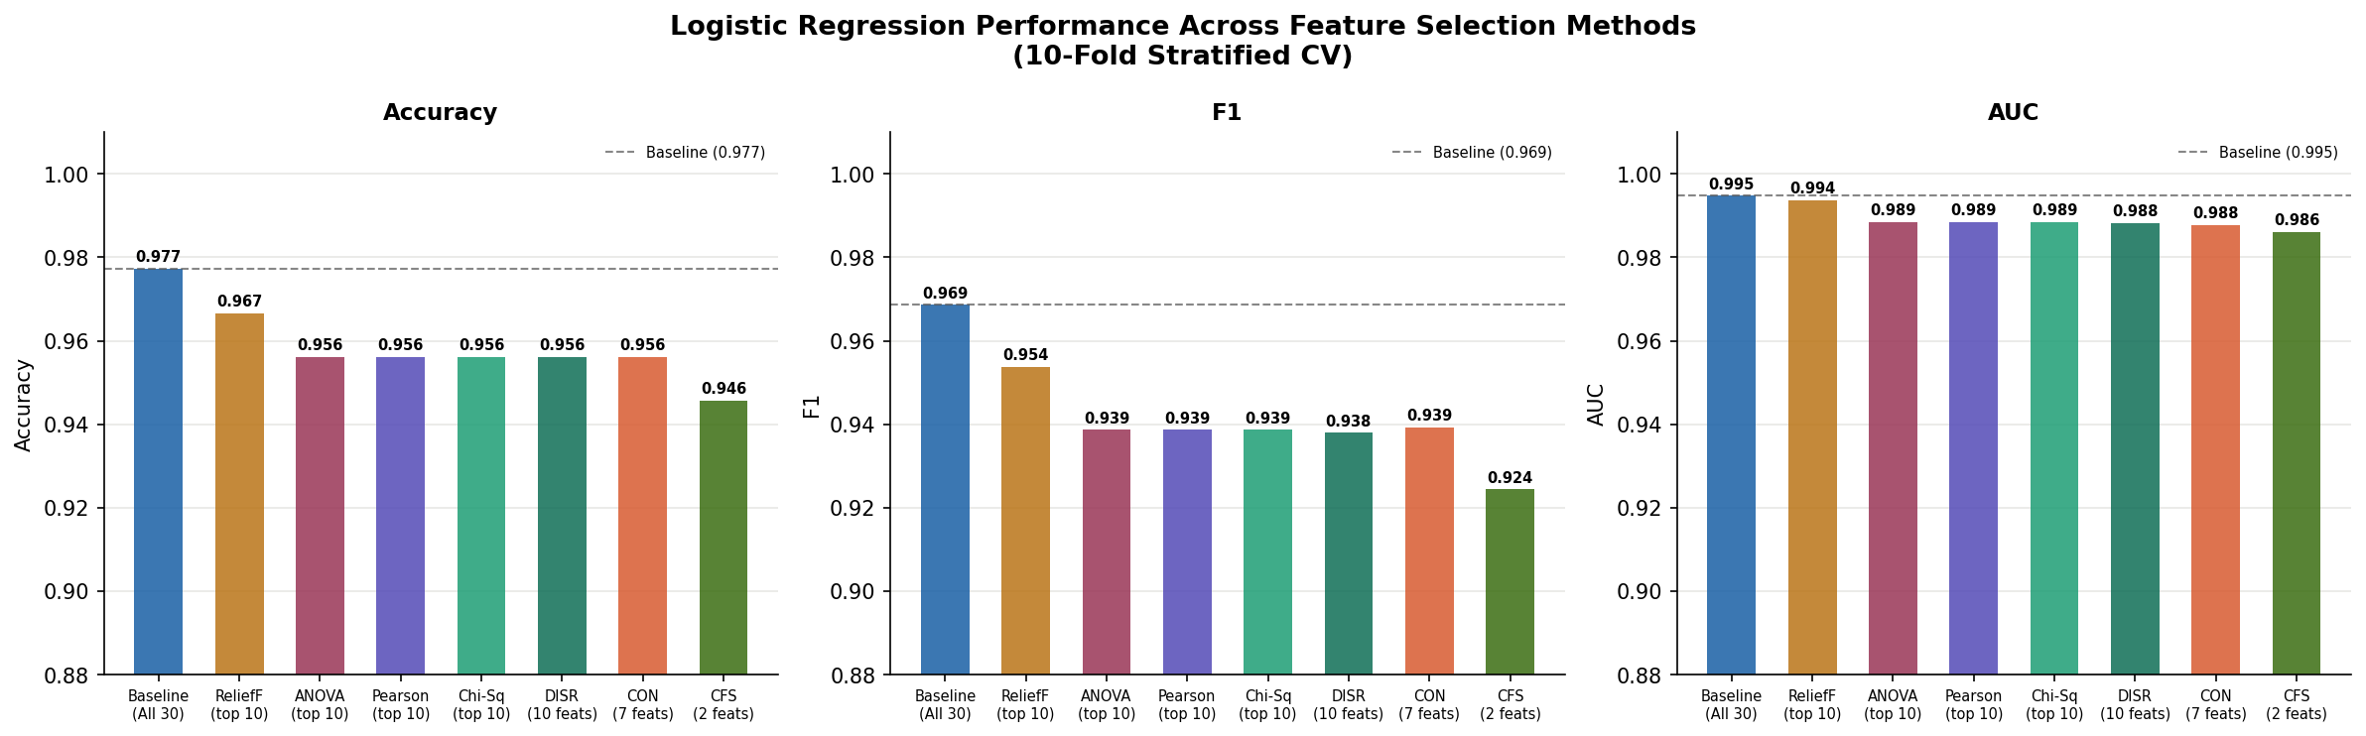
Figure 7. Model performance comparison across all feature selection methods on Accuracy, F1, and AUC-ROC. Dashed lines indicate baseline performance. All methods use Logistic Regression with 10-fold stratified cross-validation.

6.2 Feature Selection Overlap
The chart below shows which features each method selects. Features selected by many methods can be considered robust and strongly predictive. Features unique to one method reveal different perspectives on the data structure.

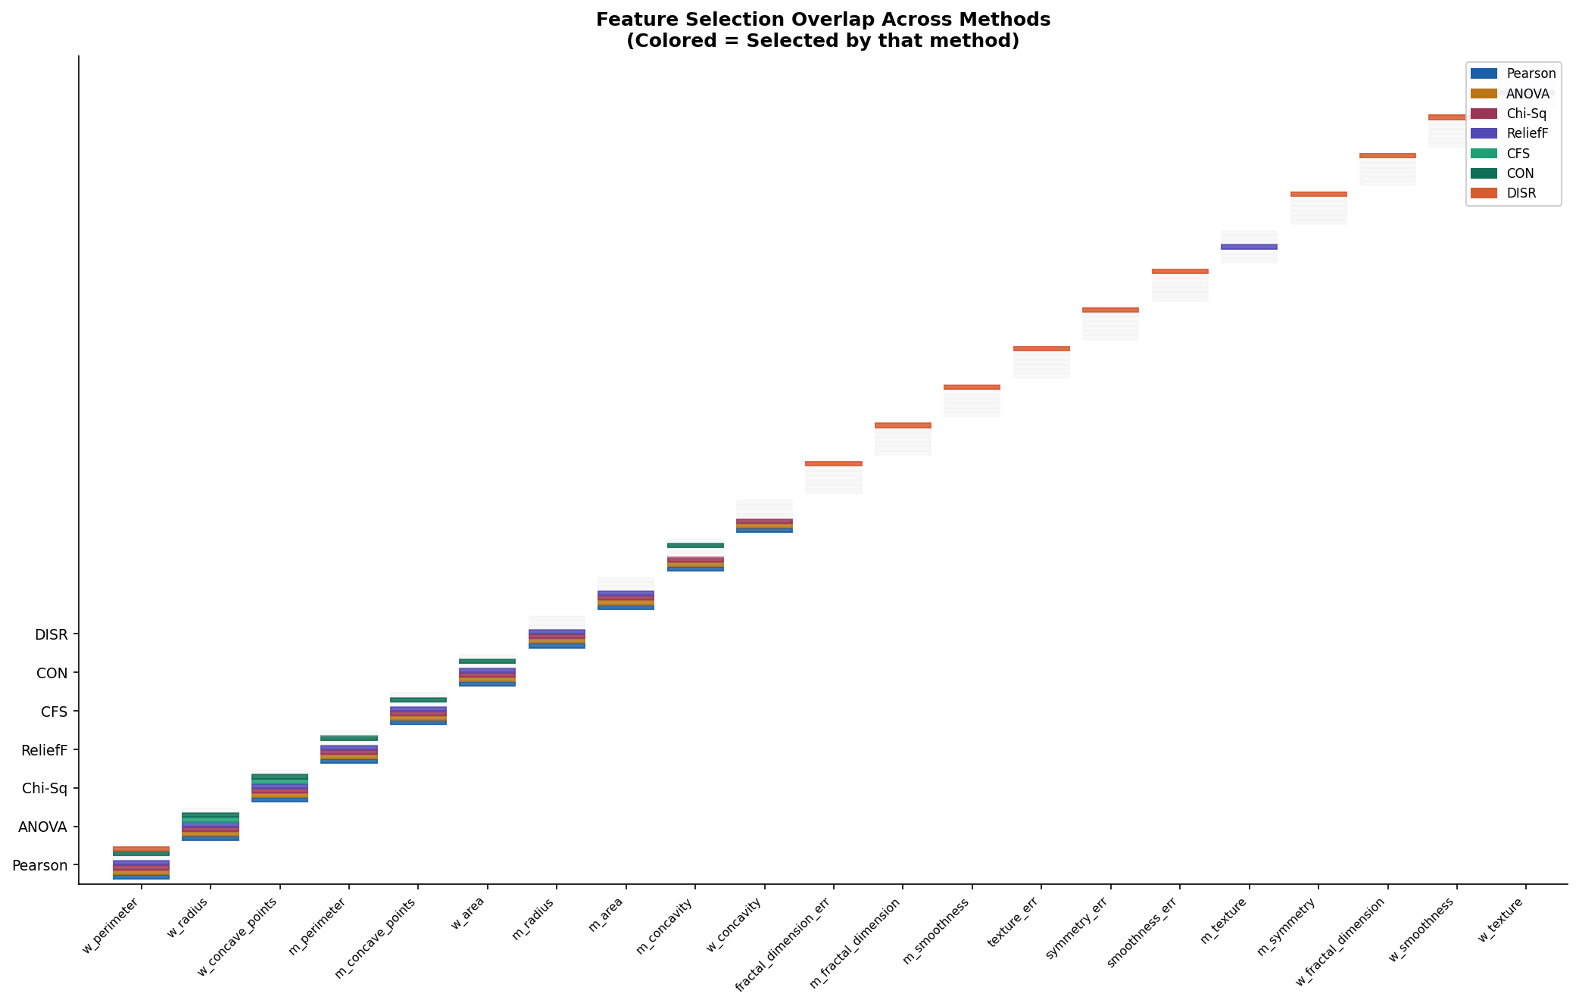
Figure 8. Feature selection overlap matrix across all methods. Coloured cells indicate the feature was selected by that method; grey dashed cells indicate it was not selected.

6.3 Full Metric Comparison
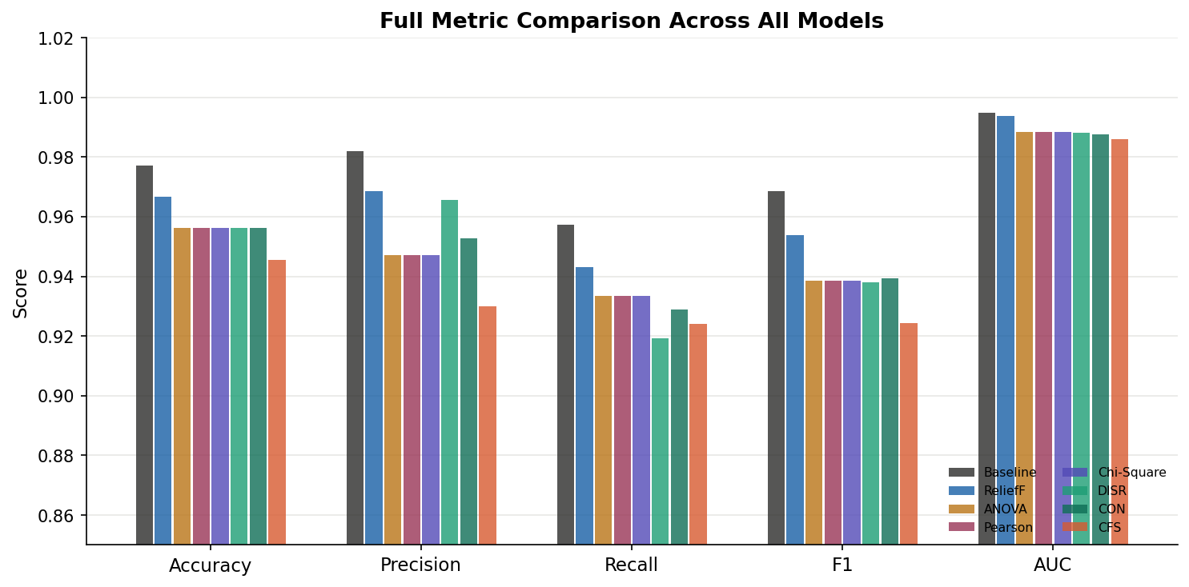
Figure 9. Full metric comparison (Accuracy, Precision, Recall, F1, AUC) across all models. The baseline achieves the highest scores but uses all 30 features.

6.4 Consolidated Results Summary
Method | Type | N Feats | Accuracy | Precision | Recall | F1 | AUC
Baseline (All 30) | — | 30 | 0.9772 | 0.9820 | 0.9574 | 0.9686 | 0.9947
Pearson r | Uni | 10 | 0.9561 | 0.9471 | 0.9335 | 0.9387 | 0.9885
ANOVA F-test | Uni | 10 | 0.9561 | 0.9471 | 0.9335 | 0.9387 | 0.9885
Chi-Square | Uni | 10 | 0.9561 | 0.9471 | 0.9335 | 0.9387 | 0.9885
ReliefF | Uni | 10 | 0.9667 | 0.9687 | 0.9431 | 0.9538 | 0.9937
CFS | Multi | 2 | 0.9456 | 0.9300 | 0.9240 | 0.9244 | 0.9860
CON | Multi | 7 | 0.9561 | 0.9528 | 0.9288 | 0.9392 | 0.9877
DISR | Multi | 10 | 0.9561 | 0.9655 | 0.9193 | 0.9379 | 0.9881

7. Discussion: Pros, Cons, and Impact on Prediction

7.1 Univariate Methods

7.1.1 Pearson Correlation, ANOVA F-Test, and Chi-Square
Method | Advantages | Limitations
Pearson r | Fast (O(np)); easy to interpret; no hyperparameters; well-understood statistically | Assumes linearity; ignores redundancy; can select many correlated features; sensitive to outliers
ANOVA F-test | Statistically grounded; provides p-values for significance testing; works well for normally distributed features | Same as Pearson (equivalent ranking for binary targets); assumes homoscedasticity; ignores inter-feature dependencies
Chi-Square | Non-parametric; works with any feature type after binning; robust to distributional assumptions | Sensitive to binning strategy for continuous features; same redundancy blind-spot; ranking nearly identical to Pearson/ANOVA here
ReliefF | Non-parametric; captures feature interactions via nearest-neighbour structure; handles both linear and non-linear relationships; more robust to correlated features | Computationally expensive O(n²p); sensitive to k parameter; stochastic results; does not eliminate redundancy explicitly
CFS | Explicitly eliminates redundancy; produces compact subsets; accounts for inter-feature correlation; theory-grounded merit function | Greedy search may miss optimal subsets; can be overly aggressive (only 2 features here); merit function is heuristic
CON | Produces the minimum set needed for consistent classification; interpretable threshold-based criterion; order-independent of discretization | Sensitive to discretization and threshold choice; relies on greedy ordering; inconsistency rate is an approximation on continuous data
DISR | Information-theoretic foundation; explicitly targets complementary features; captures non-linear, joint dependencies; most theoretically principled | Computationally expensive (O(n²p)); requires discretization; sensitive to bin count; results can differ significantly from correlation-based methods

7.2 Impact on Prediction Performance
Several important patterns emerge from the experimental results:

Pattern 1: Pearson ≈ ANOVA ≈ Chi-Square for Binary, Continuous Features
All three methods produced identical model results (Acc: 0.9561, AUC: 0.9885). This is theoretically expected: for binary classification with continuous features, ranking by |r|, F-statistic, and Chi-square all approximate the same underlying measure of marginal association. Practitioners should choose based on assumptions (normality for ANOVA, linearity for Pearson, binning strategy for Chi-square) rather than expecting different results.

Pattern 2: ReliefF Outperforms Other Univariate Methods
ReliefF achieved notably better performance (Acc: 0.9667, AUC: 0.9937) compared to the three correlation-based univariate methods, despite selecting the same number of features (10). The key advantage is that ReliefF evaluates features in the context of their local neighbourhood — it detects features that are discriminative even when the relationship is non-linear or conditional on nearby samples. This makes it more suitable for complex medical datasets.

Pattern 3: CFS Achieves Remarkable Compression at a Performance Cost
CFS selected only 2 features (worst concave points and worst radius) yet still achieved 94.6% accuracy and 0.986 AUC. This 93% reduction in dimensionality (from 30 to 2 features) is remarkable — these two features alone capture the essential signal in the dataset. For resource-constrained clinical deployment, a 2-feature model is dramatically easier to implement and explain. The performance gap versus baseline (1.2% accuracy, 0.009 AUC) may be acceptable for practical applications.

Pattern 4: CON and DISR Achieve Pareto-Optimal Trade-offs
CON (7 features) and DISR (10 features) both achieved 95.6% accuracy and ~0.988 AUC — essentially identical to the three univariate methods with 10 features, but with substantively different feature subsets. This suggests that multiple distinct feature sets can achieve similar predictive performance, and that the choice between them should be guided by clinical interpretability and redundancy considerations, not purely by cross-validation scores.

Pattern 5: The Performance-Interpretability Trade-off
The baseline with all 30 features achieved the highest scores but is the least interpretable and most prone to multicollinearity in logistic regression. CFS with 2 features is the most interpretable and deployable, but loses the most performance. Methods selecting 7–10 features (CON, DISR, ReliefF, Pearson) occupy the sweet spot: sufficient dimensionality reduction for interpretability with minimal performance loss.

7.3 Clinical Implications
From a clinical perspective, breast cancer classification using FNA biopsy data has several important considerations:
- Recall (sensitivity) is the most critical metric for cancer screening — a false negative (missed malignancy) has severe consequences. The baseline achieves 95.7% recall, while reduced feature sets achieve 92–94%.
- For clinical deployment, the 2-feature CFS model (worst concave points + worst radius) is attractive for its simplicity and interpretability, but its lower recall (92.4%) compared to the baseline (95.7%) means roughly 3% more malignant cases would be missed.
- ReliefF's feature set (including both "mean" and "worst" versions of size and texture features) may provide better generalizability across different imaging systems and biopsy protocols.
- Multivariate methods, particularly CFS, confirm that tumour size and shape irregularity ("worst" features measuring the most extreme cell nuclei observed) are the primary drivers of malignancy, consistent with pathological understanding of cancer progression.

7.4 Recommendations
Based on the experimental results and method analysis, we offer the following recommendations for feature selection in breast cancer classification:
- Use ReliefF if you are limited to univariate selection — it consistently outperforms Pearson/ANOVA/Chi-Square on this dataset without requiring strong distributional assumptions.
- Apply CFS for deployment-oriented models where interpretability and model simplicity are paramount — the 2-feature model is highly deployable while maintaining clinically acceptable performance.
- Use CON for minimum adequate feature sets when there is a specific consistency threshold requirement from clinical guidelines.
- Apply DISR when seeking the most information-theoretically justified feature set, especially if joint feature effects are suspected.
- Validate all feature selection decisions across multiple evaluation seeds and folds — the high performance on this dataset reflects its relative cleanliness; real-world datasets may require more cautious evaluation.
- Combine feature selection with domain expertise: the consistent selection of "worst concave points," "worst perimeter," and "worst radius" across multiple methods provides strong evidence for their clinical validity.

7.5 Conclusion
This study systematically evaluated seven feature selection methods — four univariate (Pearson Correlation, ANOVA F-test, Chi-Square, ReliefF) and three multivariate (CFS, CON, DISR) — for breast cancer prediction using Logistic Regression on the Wisconsin Breast Cancer Diagnostic dataset.

Key conclusions:
- All feature selection methods achieved >94% accuracy and >0.986 AUC with the reduced feature sets, demonstrating that the dataset contains strong, redundant signals that can be compressed substantially without major performance loss.
- Univariate methods based on linear correlation (Pearson, ANOVA, Chi-Square) produced identical results and are interchangeable for this dataset. ReliefF is preferred among univariate methods due to its sensitivity to non-linear interactions.
- Multivariate methods were more conservative in feature selection. CFS produced the most compact representation (2 features), while CON and DISR provided intermediate solutions. All three achieved similar predictive performance to the linear univariate methods.
- The baseline 30-feature model retains a meaningful performance advantage (especially in recall), suggesting that the additional features, despite their multicollinearity, contribute non-redundant signal that simpler feature subsets cannot fully replace.
- Feature selection is not merely a performance optimization — it is a tool for model transparency, interpretability, and deployability. The choice of method should balance predictive performance, interpretability, computational cost, and clinical requirements.

References
Hall, M. A. (1999). Correlation-based feature selection for machine learning. University of Waikato.
Kira, K., & Rendell, L. A. (1992). The feature selection problem: Traditional methods and a new algorithm. AAAI.
Liu, H., & Setiono, R. (1996). A probabilistic approach to feature selection. ICML.
Meyer, P. E., & Bontempi, G. (2006). On the use of variable complementarity for feature selection in cancer classification. EvoWorkshops.
Street, W. N., Wolberg, W. H., & Mangasarian, O. L. (1993). Nuclear feature extraction for breast tumor diagnosis. SPIE Proc. 1905.
Wolberg, W. H. (1992). Breast Cancer Wisconsin (Diagnostic) Dataset. UCI Machine Learning Repository. https://archive.ics.uci.edu/dataset/17/breast+cancer+wisconsin+diagnostic

